TRAFFIC MANAGEMENT USING IoT



**Team member**

**610821106097-SEKAR M**

**Phase 2 Submission Document**

**Project :** 223933 Traffic Management System

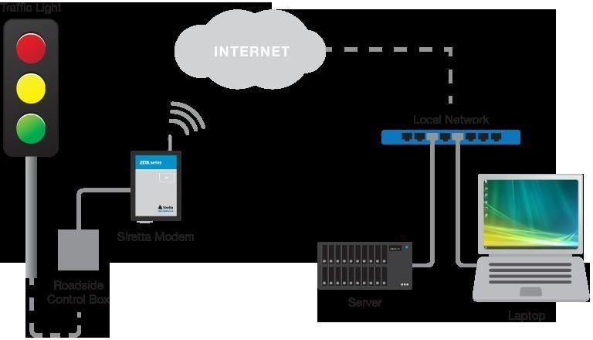

**Definition:**

An Internet of Things (IoT)-enabled intelligent traffic management system can solve pertinent issues by leveraging technologies like wireless connectivity & intelligent sensors

Phase 2 innovation:



Integrating historical traffic data and machine learning algorithms to predict congestion patterns for a traffic management system using IoT (Internet of Things) can significantly enhance traffic management and improve the overall traffic flow in a city or region. Here's a step-by-step guide on how to approach this integration:

**Data Collection through IoT Sensors:**

Deploy IoT sensors, such as cameras, vehicle detectors, GPS trackers, and environmental sensors, throughout the area you want to monitor.

These sensors will collect real-time data on traffic conditions, including vehicle counts, speed, location, and environmental factors like weather and air quality.

**Data Storage and Management:**

Set up a centralized database or data storage system to collect and store the data from IoT sensors.

Ensure data quality and consistency by cleaning and preprocessing the incoming data, handling missing values, and performing data validation.

**Historical Data Accumulation:**

Accumulate historical traffic data over an extended period. This historical data will serve as the training dataset for your machine learning models.

**Feature Engineering:**

Create relevant features from the collected data that can help in predicting congestion, such as time of day, day of the week, weather conditions, road type, and special events.

**Machine Learning Model Selection:**

Choose appropriate machine learning algorithms for predicting traffic congestion. Common choices include decision trees, random forests, support vector machines, or deep learning models like neural networks.

**Data Splitting:**

Split your historical data into training and testing datasets. Typically, you'll use a significant portion of the data for training and reserve a smaller part for testing and model validation.

**Model Training:**

Train your chosen machine learning models on the training dataset using relevant features.

Experiment with different algorithms and hyperparameters to find the model that provides the best predictions.

**Model Evaluation:**

Evaluate your machine learning models using the testing dataset to assess their performance. Common evaluation metrics include accuracy, precision, recall, F1- score, and Mean Absolute Error (MAE).

**Real-Time Data Integration:**

Integrate real-time data from IoT sensors with your trained machine learning model. Continuously feed the model with new data to make real-time congestion predictions.

**Visualization and Alerts:**

Create a user-friendly dashboard or visualization tool that displays real-time traffic conditions and congestion predictions.

Set up alerting mechanisms to notify traffic management authorities or users of potential congestion or traffic incidents.

**Adaptive Traffic Management:**

Develop traffic management strategies that can adapt based on the predictions. For example, dynamically adjust traffic signal timings, suggest alternative routes to drivers, or communicate congestion information to public transportation systems.

**Continuous Improvement:**

Continuously collect new data to improve the accuracy and effectiveness of your machine learning models.

Periodically retrain your models to adapt to changing traffic patterns and conditions.

**Privacy and Security:**

Ensure that data privacy and security measures are in place to protect sensitive information collected by IoT sensors.

By integrating historical traffic data, real-time IoT data, and machine learning algorithms, you can create a robust traffic management system that can predict congestion patterns, optimize traffic flow, and ultimately reduce traffic congestion and improve transportation efficiency in your area.